**Project Design Phase-II**

**Data Flow Diagram & User Stories**

|  |  |
| --- | --- |
| Date | 03 October 2022 |
| Team ID | PNT2022TMID15210 |
| Project Name | Smart Farmer – IoT Enabled Smart Farming Application |
| Maximum Marks | 4 Marks |

**Data Flow Diagrams:**

A Data Flow Diagram (DFD) is a traditional visual representation of the information flows within a system. A neat and clear DFD can depict the right amount of the system requirement graphically. It shows how data enters and leaves the system, what changes the information, and where data is stored.

Fertilizers Recommendation System For Disease Prediction

**Example: [(Simplified)](https://developer.ibm.com/patterns/visualize-unstructured-text/)**

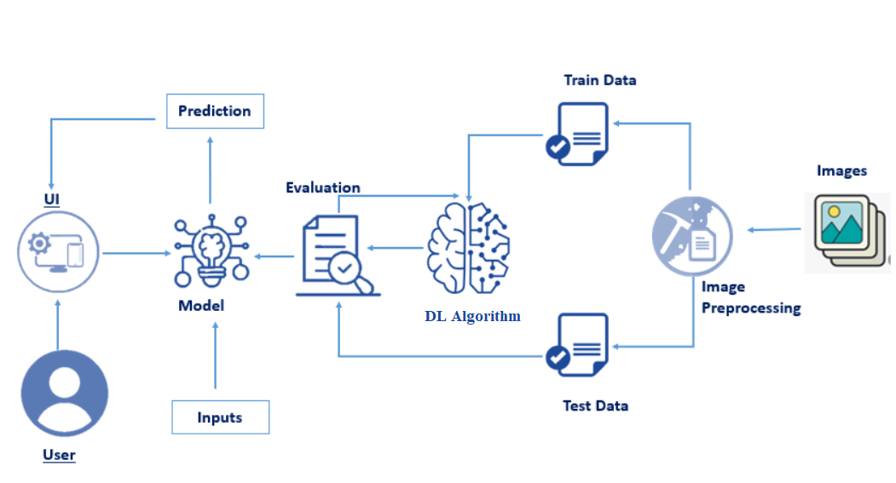

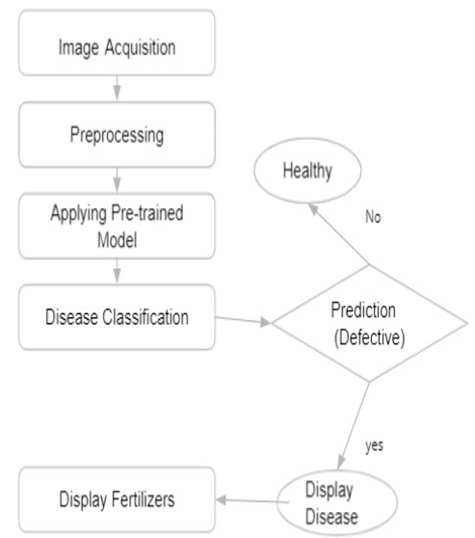

**User Stories**

| **User Type** | **Functional Requirement (Epic)** | **User Story Number** | **User Story / Task** | **Acceptance criteria** | **Priority** |
| --- | --- | --- | --- | --- | --- |
| Customer (Mobile user) | Download the database | USN-1 | As a user, I can register for the application by entering my email, password, and confirming my password. | I can access my account / dashboard | High |
|  | Register | USN-2 | As a user, I can register for the application by entering my email, password, and confirming my password. | I can receive confirmation email & click confirm | High |
|  | Login | USN-3 | As a user, I will receive confirmation email once I have registered for the application | I can register & access the dashboard with Facebook Login | Low |
|  | Upload the image | USN-4 | As a user, I must upload the image to identify the disease |  | Medium |
| Customer (Web user) | The functional requirements are same as mobile user | Same as mobile user | Same as mobile user | Same as mobile user | High when compared to mobile users |